**Linear Systems with Two Unknowns Geometrically**

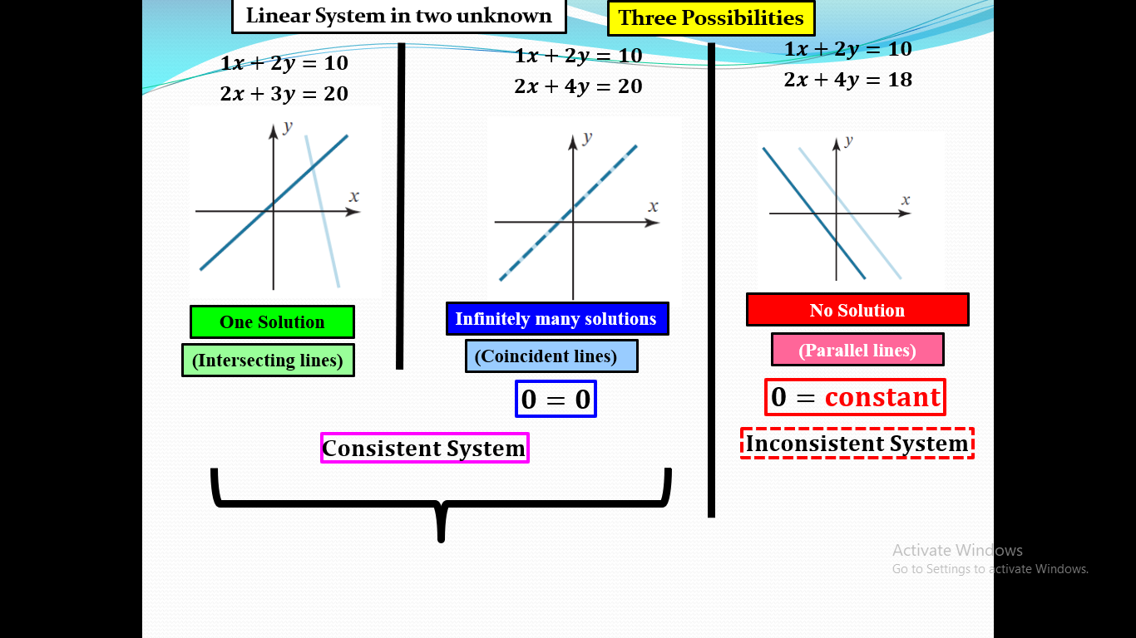

**EXAMPLE 1 A Linear System with One Solution**

Solve the linear system

$$\left\{\begin{aligned}x-y=1 \\ 2x+y=6\end{aligned}\right.$$

**Solution** ….. Verify that the system has the unique solution $x=\frac{7}{3}, y=\frac{4}{3}$

**EXAMPLE 2 A Linear System with No Solutions:**

Solve the linear system

$$\left\{\begin{aligned}x+y=4 \\ 3x+3y=6\end{aligned}\right.$$

**Solution:** Check yourself--------- $0=6.$

This is not possible, so the given system has no solution. Geometrically, this means that the lines corresponding to the equations in the original system are parallel and distinct.

**EXAMPLE 3 A Linear System with Infinitely many Solutions**

Solve the linear system

$$\left\{\begin{aligned}4x-2y=1 \\ 16x-8y=4\end{aligned}\right.$$

**Solution:** …. The solutions of the system are those values of *x* and *y* that satisfy the single equation. Let $y=t$, So

$$x=\frac{1}{4}+\frac{1}{2}t$$

$\left(\frac{1}{4}+\frac{1}{2} t, t\right), t∈R$ is solution of given system.

We can obtain specific numerical solutions for different $t$. If $t=0$, yields the solution $\left(\frac{1}{4},0\right)$, $t=1$, yields the solution $\left(\frac{3}{4},1\right)$.

**Linear Systems with Three Unknowns Geometrically**

The same is true for a linear system of three equations in three unknowns

$$\left\{\begin{aligned}a_{1}x+b_{1}y+c_{1}z=d_{1} \\ a_{2}x+b_{2}y+c_{2}z=d_{2} \\ a_{3}x+b_{3}y+c_{3}z=d_{3}\end{aligned}\right.$$

in which the graphs of the equations are planes. The solutions of the system, if any, correspond to points where all three planes intersect, so again we see that there are only three possibilities—no solutions, one solution, or infinitely many solutions:

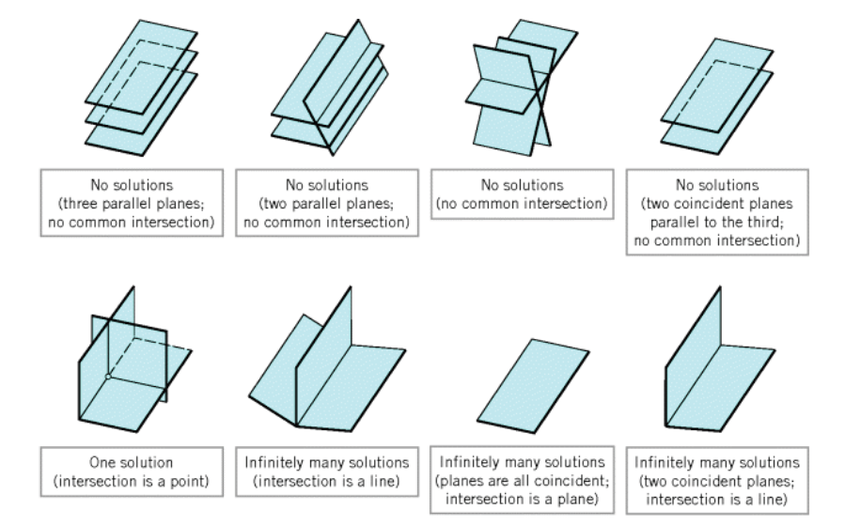

**Important Note!**

Every system of linear equations has zero, one, or infinitely many solutions. There are no other possibilities.

**EXAMPLE 4** Solve the linear system

$$\left\{\begin{aligned}x+y+2z=9 ⇢(1) \\ 2x+4y-3z= 1 ⇢(2) \\ 3x+6y-5z=0 ⇢(3)\end{aligned}\right.$$

**Solution:**

Using (1) and (2)

$$2x+2y+4z=18 \\ +2x+4y-3z=1$$

* - + -

------------------------------------------------------

$$-2y+7z=17 ⇢(4)$$

Using (1) and (3)

$$3x+3y+6z=27 \\ +3x+6y-5z=0$$

* - + -

------------------------------------------------------

$$-3y+11z=27 ⇢(5)$$

Using (4) and (5)

+ - -

------------------------------------------------------

Put $z=3$ in equation (4)

$$-2y+7\left(3\right)=17$$

$$-2y+2=17 \\ y=2$$

Put $y=2$ and $z=3$ in equation (1).

$$x=9-2-2\left(3\right) \\ x=1$$

So the solution of given system is $\left(1, 2, 3\right)$, which is unique.

Geometrically it represents that three planes intersect at unique point.

**EXAMPLE 5**

Solve the linear system

$$\left\{\begin{aligned}x-y+2z=5 \\ 2x-2y+4z=10 \\ 3x-3y+6z=15\end{aligned}\right.$$

**Solution:**

This system can be solved by inspection, since the second and third equations are

multiples of the first. Geometrically, this means that the three planes coincide and that those values of *x*, *y*, and *z* that satisfy the equation

$$x-y+2z=5 → (1)$$

Automatically satisfy all three equations. Thus, it suffices to find the solutions of (1). We can do this by first solving (1) for *x* in terms of *y* and *z*, then assigning arbitrary values $s$ and $t$ (parameters) to these two variables and then expressing the solution by the three parametric equations

$$y=t, z=s⇒x=5+t-2s$$

So $(5+t-2s, t, s)$ is the solution of the above system.

Specific solutions can be obtained by choosing numerical values for the parameters *t* and *s*. For example, taking $t=1$ and $s=0$ yields the solution $(6, 1,0).$

Note: Geogebra for visualization of solutions and geometry.

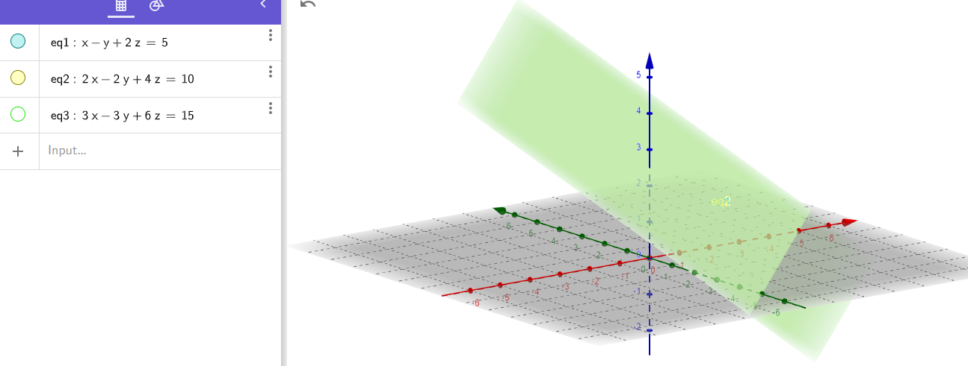

**Work to do**

1. Solve the following linear system of equations:

$\left\{\begin{aligned}2x+4y+6z=-12 \\ 2x-3y-4z=15 \\ 3x+4y+5z=-8\end{aligned}\right.$

**Exercise 1.1 Q 6-14**

**Single linear equation ye bata rhi hae , k infinite solution baaki b same hain ,**

**In that case we would assume the remaining variables to be t ,s etc aur phir depending on number of variables apna order pair bana lein gae;)**

1. In each part, find the solution set of the linear equation by using parameters as necessary.

$7x-5y=3$

$-8x_{1}+2x_{2}-5x_{3}+6x_{4}=1$

**Homogeneous Linear System**

A system of linear equation is said to be homogeneous if it’s constant term is equal to zero. **For example**

$$3x+4y=0$$

$$-2x+5y=0$$

* Every system of linear equations is consistent because all such systems have $x=0, y=0$ as a solution. This solution is called **trivial solution**. If there are other solutions, they are called **non trivial solutions (**infinite many solutions**)**.
* A homogenous system always has the trivial solution. There are only two possibilities for its solutions:

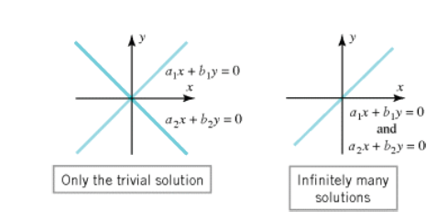

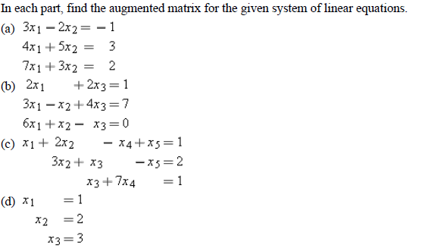Q14.

Q. In parts (a)–(h) determine whether the statement is true or false, justify your answer.

**(a)** A linear system whose equations are all homogeneous must be consistent.

**(b)** Multiplying a linear equation through by zero is an acceptable elementary row

operation.

**(c)** The linear system



cannot have a unique solution, regardless of the value of *k*.

**(d)** A single linear equation with two or more unknowns must always have infinitely

many solutions.

**(e)** If the number of equations in a linear system exceeds the number of unknowns, then

the system must be inconsistent.

**(f)** If each equation in a consistent linear system is multiplied through by a constant *c*,

then all solutions to the new system can be obtained by multiplying solutions from

the original system by *c*.

**(g)** Elementary row operations permit one equation in a linear system to be subtracted

from another.

**(h)** The linear system with corresponding augmented matrix



is consistent.